**Lab 52**

***Fill in the indicated code described in the statements in bold to complete the below program. Then compile and run the program several times with various inputs. Try all the possible relevant cases and record your results. What do you think will happen if you do not enter A, B, C, D or E? Try running the program and inputting another letter. Take a screen shot of the output.***

Before I give my answer, I'd like to state that I think there are some errors on how we were told to write this program. The question above that asks "***What do you think will happen if you do not enter A, B, C, D or E?"*** only works if E (or e) is a valid option. But the instructions didn't state to write a case E (or e) on the first switch, only on the second switch which is found inside the if statement. So the option E will always be "false" on the first switch. We were also not instructed to place an E option on the menu interface which is found between lines 29 and 35 (on my cpp) inside the do while loop. So the user does not know that an E option exists. So in short, entering E doesn't display anything. Entering a numeric value like 4 doesn't do anything either. Here are the outputs of A, B, E and 4:

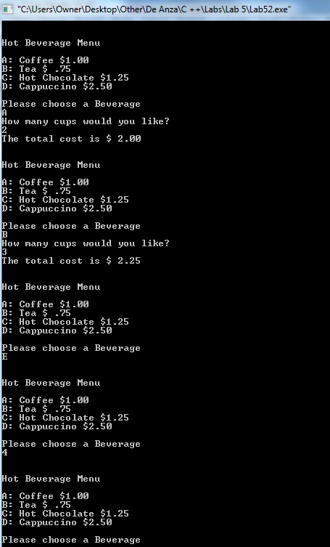

Having said that, I will answer the above question regarding the E option, assuming it is supposed to exist on the first switch. In theory, entering an E option should display a message stating: "Please come again". In my cpp though, it doesn’t (because I did not enter a case e/case E on the first switch). But I'm still going to provide that output, in case its needed for this lab. I added a case E on the first switch, and then deleted it. This was the output of "e":

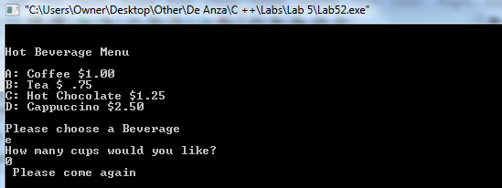

Likewise, This would be the output of an f, if the default was to be put in use:

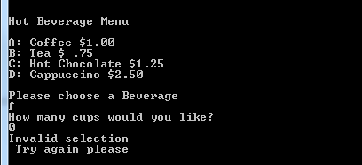

***Replace the line:***

***if (validBeverage == true) with the line if (validBeverage)***

***and run the program again. Are there any differences in the execution of the program? Why or why not? Take a screen shot of the output.***

There are no differences, they are equivalent. This is due to the fact that the "if" statements have their specific actions based on whether or not the condition expressed exists. If it exists then it's true. If it doesn’t its false. Here is a screenshot using "if (validBeverage)":

